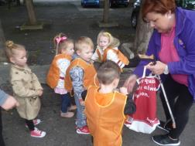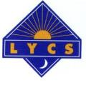

**Annual Review 2016**

**Lourdes**

**Youth & Community Services**

**Crèche**

**\***

**Youth Work Programme**

**\***

**Community Training Centre**

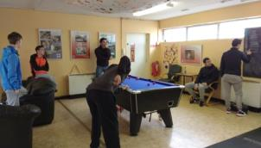**\***

**Adult Education Programme**

**\***

**Development Education**

**\***

**Community Employment**

**



**Overview of LYCS in Numbers**

**Childcare (1-5yr olds)**

* 80 children in crèche
* 20% children live in homeless accommodation

**Youth Work Programme (10-21yr olds)**

* 78 participants
* 51 attended Summer Programme
* 16 water safety programme
* 4 residential trips to Wexford Centre

**Community Training Centre (16-21yr old early school leavers)**

* 55% of those who left got a job or progressed onto further education
* 35 early school leavers were awarded 140 Certificates in FETAC Level 3 & 4-
* In 2016 nearly 30% of young people attending the centre were living in care homes or homeless accommodation

**Community Employment Scheme**

* 41 participants
* 13 participants left CE in 2016, **54%** progressed onto employment/education
* 20 participants took part in certified training
* 11 participants took part in uncertified training
* 4 achieved FETAC Major Award
* 11 achieved FETAC Minor Awards

**Adult Education Programme**

* 130 local people registered for courses in 2016
* 102 adults were awarded 133 participation certificates
* 150 adults received training who have little or no experience of using a computer

**Development Education**

* 310 people engaged in DE activities as a result of LYCS training community educators
* 83 people participated in direct DE training countrywide

***Over 300 people accessed LYCS services each week***

***Our threshold was crossed over 15,000 times in 2016***

***Contents: Page:***

**LYCS in Numbers 2**

**Philosophy of LYCS 4**

**Overview: Director / Chairperson 5**

**Profile of LYCS 6**

**LYCS’s Programmes of Activity 9**

* **Crèche 9**
* **Youth Programme 12**
* **Halloween Festival 16**
* **Community Training Centre 17**
* **Community Employment Scheme 20**
* **Adult Education Programme 22**
* **Development Education 25**

**Management Board 26**

**Acknowledgements *27***

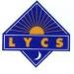

**Philosophy**

***To encourage people to be aware of their own power and how they can use it to effect change, and that every person has the right to participate fully in their own, their communities, and their country’s development.***

**LYCS programmes and activities.**

To address the diverse needs of the local community LYCS operates the following programmes:

**First Steps Crèche and Preschool**

LYCS First Steps provides 80 places for children from 1-5 years each day in our crèche including free Pre-School Places. Many of the parents of the children who use the crèche are drawn from all four programmes within LYCS and live locally.

**Youth Work Programme**

The Youth Work Programme offers afternoon, evenings and weekend programmes plus regular trips outside of Dublin for up to

80 young people aged 10-21 years.

**Community Training Centre (CTC)**

40 Early School Leavers have the opportunity to gain certified training in FETAC Levels 3 & 4 in a range of modules and subjects.

**Adult Education Programme**

Provides informal training and education for over 70 women and men each week, all of whom have little or no history of formal education.

**Development Education**

LYCS facilitates the promotion of development education within the community development / education sector in Dublin’s North Inner City and across Ireland.

**Community Employment Scheme**

LYCS operates a CE Scheme with 36 participants some of whom are based in LYCS while others are placed in community projects throughout the

north inner city.

**Overview of 2016**

**\* Childcare * Community Training Centre * Youth Programme \***

**\* Adult Education Programme * Development Education \***

**\* Community Employment Scheme \***

Despite resources and funding remaining scarce, 2016 was another eventful year for LYCS. Over 300 participants achieved many goals as they worked hard to engage in the wide variety of educational, training and social programmes on offer in the project.

In the past year, local people continued to suffer the effects of many years of austerity which have impacted all sections of Irish society. Coupled with decades of social disadvantage, generational unemployment and widespread drug/alcohol misuse a large proportion of the local population could not participate in a meaningful way in the economy. The rise in the use of drugs, in particular tablets, has made the local environment more challenging and less safe for everyone.

We, in LYCS, believe that increased levels of education and training are required if people are to access stable, adequately paid employment and benefit from the fruits of the apparent economic recovery. Our challenge for 2017 is to continue to actively engage local people in a positive way and to act as a haven and hub of hope and development in order to counter the negative social and economic challenges facing the community in the north inner city.

**Refurbishment of Rutland Street School**

The community received confirmation in February 2017, as part of the North East Inner City Task Force, that the old Rutland Street School will be refurbished into a thriving community education centre. This facility will become a valuable resource for the local community into the future. The City of Dublin Education and Training Board have proposed the merger of North City Centre Community Action Project (NCCCAP) and the Adventure Sports Project (ASP) with LYCS and both will form part of discussions in 2017. There has been a huge level of positive local support for this development. The refurbishment process will begin in 2017 and is expected to take two years to complete.

**Dublin Inner City Community Co-Op**

LYCS is a founder member of the newly formed Co-Op This is an exciting new phase for the 13 community development organisations who have come together to create a cohesive approach to the delivery of services for the most disadvantaged areas in Dublin’s Inner City.

We would like to take this opportunity to thank staff and volunteers for their contribution, energy, commitment and continuous sense of humour, which they bring to work every day – without which LYCS would not be the hive of activity that it is. Thanks are also due to the members of the Management Board for their on-going, voluntary commitment, which is very much appreciated. We hope you enjoy reading this report and do contact us if you would like any more information about LYCS.

***Sarah Kelleher Jackie Lawlor***

***Director Chairperson, Management Board***

logo**Profile of LYCS and the north inner city.**

Lourdes Youth & Community Services (LYCS) was established in 1984, as part of a broad based community development movement, which emerged in Dublin’s north inner city in the late 1970’s and 1980’s.

LYCS is an integrated community based *education, training, recreation and development* project which is concerned with giving participants the opportunity to become involved in their own development and the development of their community. The organisation is locally based and participatory. Personal and social development are seen as inextricably linked to the development of local community resources.

## Catchment Area

LYCS services Dublin’s north east inner city area which has a population of **33,790** (Census 2011) and is one of the most disadvantaged areas in Ireland. The 2011 Census shows an increase of over 10,000 people since 1991 in our immediate locality. Nearly one third of the inner city population is aged 24 and under.

**Population of North East Inner City, 1991-2011**

The population has increased dramatically since 1991 with substantial numbers of people moving into the area.  This trend may be attributed to the stabilisation of the local authority housing complexes and developments in the North Docklands areas over the last decade.  These developments have given rise to a mixture of both social and affordable housing with private dwellings, shops and businesses.

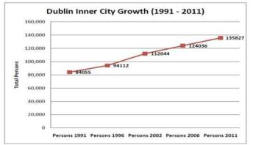When the population profile of the North East Inner City is compared with the rest of Dublin and the State, a number of distinguishing features emerge:

* **The area continues to have high levels of lone parents families with approximately 50% of households headed by a person parenting alone, primarily a woman.**
* **A relatively low proportion (6%) of people in the dependent age group of 65 years of age and over.**
* **Over 25% of the population left school before achieving a qualification at upper level secondary education.**
* **Over 75% rent their home from local authority, private landlords or voluntary bodies.**
* **Unemployment rate for Dublin in 2011 was 18.5% but north inner city was 22.2% whilst the rate in ‘very disadvantaged small area’ was as high as 51.4%**
* **47% of NEIC’s population comprised persons of foreign nationality.**

The North Inner City of Dublin which, despite some improvements resulting from State investment, remains one of the most concentrated area of disadvantage in the State. The area also features higher than average numbers of heroin abusers, homeless people, older people living alone, lone parents, local authority tenants and people dependent on rent subsidies. This has increased demand on local community and public services.

**Substance Abuse**

The use of legal and illegal substances poses a daily challenge for young people and adults in the area. Alcohol abuse results in major problems for young people causing them to miss days from schools and training centres regularly. For many young people regular use of hash is considered “normal”. There is also a general ambivalence towards the recreational use of prescription tablets which can be easily sourced on the black market.

**Criminal Activity**

There is evidence that a significant number of young people are involved in both petty criminal

activities and some, in more serious, organised crime. Some have older family members involved in the illicit drug trade, or are involved themselves.

|  |
| --- |
| **Ethnicity** |

As there has been a substantial increase in the numbers of foreign nationals moving into the local area, it is anticipated that this will impact in future numbers wishing to participate in youth and community services. Residents living in local authority housing/accommodation are more likely to be Irish. There tends to be limited movement in and out of this type accommodation and the low turn-over can be due to the eligibility criteria for the local authority housing. The comparative ethnic make-up of the resident population is graphically illustrated in the above pie-chart.

LYCS currently provides services for large numbers of people who were born outside of Ireland and delivers English for Speakers of Other Languages (ESOL) classes for adults each week.

**The North Inner City**

Since the early 1990s, Dublin’s north inner city has changed from being an area of wide-spread poverty and declining population to one of a growing population with a patchwork of considerable affluence and disadvantage at the small area level. The longer resident indigenous population often remain very disadvantaged; now their disadvantage can tend to be masked and more hidden. In broad terms there are a range of populations and communities in the north inner city inclusive of:

* An older indigenous community, with families, who reside in local authority accommodation and flat complexes in the most disadvantaged parts of the area
* A new immigrant community, resident in the private rented sector some of which is of poor quality
* A newer Irish community, less likely to have families/children than the older Irish community and living in private rented or owner occupied accommodation
* People living alone.

|  |  |
| --- | --- |
| According to the 2011 Census, 10,987 people live in areas which are assessed as either *very* *disadvantaged* or *disadvantaged* and this comprises 16.3% of the population of the north inner city |  |
|  |  |

**Family unit/Household Make Up**

In the north inner city area 50.1% of family units comprise lone parents with children of which 44.5% are headed by lone mothers. In the very disadvantaged small areas 73.0% of family units are lone parents with children with 66.0% headed by lone mothers. The comparative make-up of family units from small area to City wide level are illustrated in the four pie-charts below.

|  |  |
| --- | --- |
| **Dublin City** | **Disadvantaged Small Areas** |
|  |  |

**Population aged 15 years - highest level of education completed total**

|  |  |  |  |
| --- | --- | --- | --- |
| **Education Level** | **North**  **Inner City** | **Disadvantaged Small Areas** | **Dublin City** |
| **No Formal Education** | 709 | 80 | 4,635 |
| **Primary Education** | 5713 | 712 | 56,817 |
| **Lower Secondary** | 4822 | 478 | 50,840 |
| **Upper Secondary** | 6285 | 320 | 58,906 |
| **Technical or Vocational qualification** | 2998 | 109 | 24,356 |
| **Advanced Certificate/Completed Apprenticeship** | 1531 | 38 | 13,813 |
| **Higher Certificate** | 1754 | 12 | 12,729 |
| **Ordinary Bachelor Degree or National Diploma** | 3544 | 17 | 25,157 |
| **Honours Bachelor Degree, Professional qualification or both** | 5279 | 11 | 42,241 |
| **Postgraduate Diploma or Degree** | 5363 | 7 | 41,371 |
| **Doctorate (Ph.D) or higher** | 495 | 0 | 4,636 |
| **Not stated** | 5094 | 240 | 23,718 |
| **Total** | 43587 | 2024 | 359,219 |

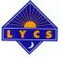

**First Steps Preschool and Crèche**

***Opening hours:***

***Monday to Friday 8:45 a.m. – 5.00 p.m.***

**Programme Activities**

* 80 children under 5 years access full-time and sessional services
* Work based training for CE Workers, College students, Transition Year students, CTC learners, Jobs Initiative Workers
* 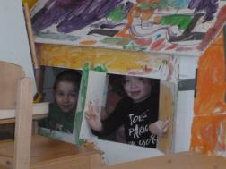Provision of a service for children whose parents access other LYCS training and from the local community.

First Steps crèche is a community crèche and all funds generated go back into developing the service and enhancing the childcare experience for all of our children. We give priority to parents who live in the local area who are returning to employment or education.

LYCS promotes:

* healthy eating and prepares freshly made breakfasts and dinners each day and strives to meet all the children’s cultural and dietary requirements.
* equality in the crèche, ensuring the diversity of the children is celebrated through the promotion of diverse reading materials, music, language and food and that a positive learning environment is created.

In 2016 we worked with children and families from 15 different countries, with many languages and cultures. There were over 25 children who are living in temporary accommodation in B & B’s or Hotels throughout the city. Referrals are made by Social Workers, Public Health Nurses, parents and Focus Ireland

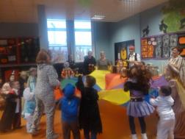Working with small children with individual needs requires staff to be observant, good listeners, patient, supportive, good communicators, creative, show respect to others, have a good imagination, be open to children’s wants and needs, good awareness, show empathy, understanding and most of all, have compassion and have fun, show love, respect and care for the children. In essence our approach is development, education and learning through play.

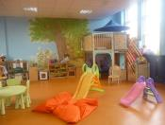

|  |  |  |  |
| --- | --- | --- | --- |
| **Children’s Groups** | | | |
| ***Morning*** |  | ***Afternoon*** | |
| Toddler | 10 | 10 | |
| Tweeny | 18 | 11 | |
| ECCE Free Pre-School | 11 | 20 | |
|  |  |  |  |
| Total number of children | 80 |  |  |

**Overview of the year**

* New childcare regulations led to changes in the numbers of children in each room.
* New extra ECCE Free preschool group provided to meet with the demand.
* Afterschool group closed due to funding constrictions.
* 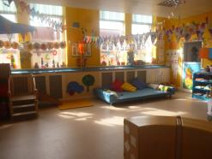Staff supported to participate in Honors Degree in Early Childhood Care and Education and level 6 in Early Childhood Care and Education.
* Community Employment staff were supported to participate in Level 5 and Level 6 Childcare training to enable them to access careers in Childcare.
* Fundraising events included Cake Sales and Pajama Days and parties for Easter, Halloween and Christmas.

In 2016, majority of parents were in receipt of a welfare benefit. Some parents attended LYCS programme or local colleges for training and education whilst their children attended our crèche. This gives parents the opportunity to develop and learn knowing their child is in a safe, fun, learning environment. This also gives them an opportunity for future employment which benefits themselves, their children and the community. We had 5 children with additional needs and many others who were waiting on a diagnosis of an additional need. We continued to support their needs and the needs of their families.

**Aistear and Siolta Practice Guide**

With support from the Early Learning Initiative in NCI we are continuing to work with the Aistear and Siolta Practice Guide to develop and enhance the curriculum and to promote best practice guidelines for working in early years education. The Early Learning Initiative, NCI team are also supporting us with by mentoring our team through various Numeracy projects to support children.

**Curriculum Foundations** and six interconnected **Curriculum Pillars**:

1. Building Partnerships with Parents

2. Creating and Using the Learning Environment

3. Learning through Play

Nurturing and Extending Interactions

5. Planning and Assessing using *Aistear’s* Themes

6. Supporting Transitions.

**Special Events in 2016**

The children enjoyed another **St Patricks Day Parade** in March 2016 with over 100 parents and children dressed in green for the occasion and paraded from Rutland Street, up to Summerhill, down Gardiner Street and home by Sean McDermott Street to the joy of passer-bys and cars who blew their horns. It was a colourful event enjoyed by all. Children who are progressing to primary school participate in a specially designed programme which familiarises them with the changes they can expect in school. In previous years this has proven to smooth their transition to primary school.

A **farewell party** for all the ‘Big’ children who went off to big school was held in August 2016.

The children and staff were heavily involved in the BallyMacSheriff Halloween celebration taking part in art and craft workshops as well as the main event. The children also enjoyed a Halloween Party where they dressed up as witches/princesses and various cartoon characters.

Santa made a surprise visit to our Christmas Party to give all the children lots of lovely presents.

With over 80 children at any given time we had ‘many, many, many’ Birthday Parties throughout the year!

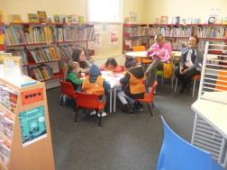In December 2016, LYCS hosted a **Christmas Lunch** for local Community Groups for the second year in the crèche. This was a great success again with over 80 community professionals attending.

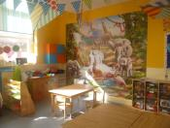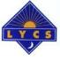**Youth Work Programme**

The Youth Work Programme is committed to providing a quality service for young people from the local community that is directed by the young people themselves and as such responds to their real needs. Programmes include:

**Youth Work Programme Groups**

* Junior Drop In (9+yrs)
* Intermediate Drop In (mixed 14-18yr olds)
* Junior Mixed Group 10-12yr olds
* Intermediate Group (Intermix mixed 15-17 yr olds)
* Junior Leaders Programme (15 – 18 yrs)
* Water Safety Programme
* Residential Weekend Programme X 4 per year in Wexford
* Summer Programme – 4 weeks
* Special activities programme:
  + Bullying
  + Development Education,
  + Anti-racism training
  + Drug awareness.
  + Mental Health issues
* Inter-generational Crafts Programme
* Soccer Programme for girls
* Educational / social trips in Dublin city
* One-to-one and group educational and employment progression support for individuals
* Drugs, Sexual Health & Health & Beauty Programme for 15-18 yrs group

**Achievements during 2016**

* 78 individual young people (32 male and 46 female) participated in programmes throughout the year.
* Over 40 young people participated in 4 weekend residential trips to the Wexford Centre.
* 6 young people completed **Irish Water Safety** certification in Rescue 3.
* Funding for a new **Junior Leadership Programme** was secured in December and will begin in early 2017. 15 young people trained in leadership skills and who volunteer in many of our programmes*.*
* The Youth Work programme began its second year of Cycle 2 of the National Quality Standards Framework (**NQSF)** process, which became the catalyst for many changes.

**The aims of the project are as follows*:***

* To prevent young people from getting involved in anti-social behaviour and drug/alcohol use through the provision of alternative programmes that meet their needs.
* To provide a dynamic range of programmes to young people from the inner city that will equip them with key skills such as communication, teamwork, youth leadership and self-initiative.
* To promote integration and share good practice through partnership projects with other youth groups in the Dublin area.
* To integrate the work of LYCS’s four programmes of activity: Community Training Centre (CTC), Adult Education Programme and Childcare Centre with the Youth Work Programme.
* To ensure that Youth Work Programme activities adhere to Health & Safety legislation.
* ****To continue to offer special activity programmes during the year and thematic projects e.g. drugs and alcohol, sexual health, nutrition and fitness educational programmes.

**Target group**

Our participants are drawn from social housing complexes locally and are considered to be at risk but may not have as yet engaged formally with the Gardai, Probation & Welfare and/or the Courts. Young people are selected on the basis that they:

* Live in the immediate local area and/or
* Referred from other services e.g. youth groups, probation and social services, local schools, Community Training Centres,

**Methodology**

LYCS uses the following methodologies in its service delivery:

* **Centre** **based** afternoon, evening and weekend programmes
* **External** residential educational programmes e.g. Wexford Centre and camping programmes; day trips outside of Dublin.
* **Drop in** –promotes recruitment of new members who then transfer to an appropriate smaller group
* **Group work** –small groups who complete a task or explore an issue e.g. arts/dance event or bullying
* **Educational development programme** - on specific topics e.g. sexual health awareness, drug/alcohol awareness, development education, anti-bullying.
* **One-to-one advocacy support** for individuals e.g. information on educational progression routes, welfare advice
* **Outreach programme** – working with other services as a means of gaining referrals, devising common solutions to problems effecting young people.



LYCS works intensively with groups of 10-15 young people in each session except for our Drop-In which could have up to 25 young people in the centre at one time. Over a week all of our young people participate in our services. Our summer programme offers intensive one day programmes for each of our groups rather than having all of our participants in the centre at any one time. This is to ensure delivery of a high quality service for individual participants but it is also at the request of the young people who showed preference for accessing intensive, mostly external, programmes, less often rather than large group centre-based activities each day.

**Programme review and project evaluation**

A relationship of respect and trust is nurtured and established between the Youth Work team and young people. A range of evaluation techniques are applied that involve young people through buzz groups, questionnaires, Individual Volunteer Profiles/Plans and group evaluation / feedback sessions, programme records and project evaluations as well as ongoing and informal feedback from the young people. All programmes are reviewed and evaluated formally at the end of each term.



**The number of young people the Youth Work programme worked with in 2015**

|  |  |  |  |
| --- | --- | --- | --- |
| **Age** | **Male** | **Female** | **TOTAL** |
| **10-21** | **32** | **46** | **78** |

|  |  |  |  |  |
| --- | --- | --- | --- | --- |
| **LYCS Youth Work Programme Time Table September 2016 – June 2017** | | | | |
| **Monday** | **Tuesday** | **Wednesday** | **Thursday** | **Friday** |
|  | | | | |
| 3:30 to 5pm **(Junior Mixed)**  5.30pm - 7.30pm  **Intermix group**  **(14 – 18 yr olds mixed)** | 5.00pm - 7.00pm  **(Drop In 12 + mixed)**  7.30pm - 10.00pm  **Junior Leadership group**  **(16 – 18yrs Mixed)** | 3.30 - 5.30pm  **Drop-In**  **(9 – 12 yr olds)**  7.00 to 9.30pm  **Inter-generational Crafts programme**  7:00 to 9:30  **Water Safety** in Belvedere College Pool | 4.00 - 6.30pm  **Drop In (all ages)**    **Arts & Crafts** | 3pm to 5.30pm  **Drop In +**  **Swimming (all ages mixed)** |
| **Weekends**  **4 x Residential trips** to the **Wexford Centre**  per year |
|  |
| **Summer Programme: 4 weeks July – August** | | | | |
| **Special activities:**   * Nail art, health & beauty, healthy cooking, sports, swimming, computers, homework, IT, media studies, art, football, educational trips around Dublin, walks, one-to-one supports to access college, volunteering, pool, games, watching matches. * **Easter, Hallowe’en and half term special programmes** * **Financial Literacy:** The Junior Leaders participated in a financial literacy programme, funded by Ulster Bank. * **Anti-Bullying programme** The staff team were trained on how to promote a ‘bullying free’ environment in an effort to tackle the high level of inappropriate language and behaviour which is used by young people against each other. | | | | |

**Residential weekends**

Four residential weekends were delivered during the year and were a real highlight for all of LYCS’s young people. The youth team deliver a variety of programmes including: night games, cycling trips, football, swimming, kite flying and trampoline games along with other group activities. While on residential trips the young people get to:

* take part in a range of outdoor programmes
* gain valuable independence and life skills
* learn to work together as a team through planning every aspect of the weekend including; menu, ground rules, cleaning rota. All the young people have a real voice in planning and have to take on key responsibilities at each residential. Mutual respect is established between the young people, youth work team and volunteers and the young people gain confidence by being away from home and trying new things.

Having the support of the Junior Leaders on each residential trip is hugely positive. Their experience gained on the Youth Work Programme over the years has meant that they are equipped to act as leaders in conjunction with the youth work staff on residential weekends.

**Summer Programme**

Features of the Summer Programme included:

* Programmes were delivered in the mornings, afternoons and evening/night time.
* Resources used included: LYCS minibus/driver, Network minibus/driver, Sean McDermott St. Swimming pool, Dart Service, LYCS premises, LYCS Adult Programme kitchen, East wall water sports.
* Sessions in East Wall Water Sports Centre where 47 young people availed of kayaking, canoeing, fun and games on the water.
* Weekly swimming sessions.
* The fine weather allowed us the opportunity of very successful day trips e.g. Forty Foot, Malahide Castle, Clara Laragh, Funtasia, Tayto Park, Footie, Pitch & Putt, Driving Range, Go Karts, Pier Jumping, Maze and Glendalough.
* Fishing trips which were enjoyed by all.



**Staff Training included:**

* 2 day Restorative Practice training which will inform how we communicate with each other and with young people. It has been hugely beneficial and useful for the team.
* First Aid Training
* Tec space training

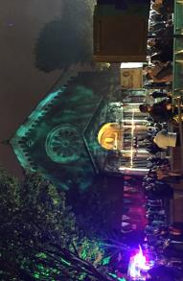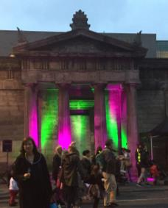

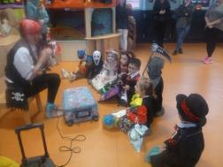**Halloween Festival**

**The BallyMacSherriff Halloween Festival** was piloted in 2016 and was the culmination of 3 months’ work with local residents and community groups in Sean McDermott Street, Sheriff Street and Ballybough. The event itself was a great success.

LYCS was an active participant in the organising the first community led Halloween festival with children, teenagers and adults taking part.

Young people from our Youth Work Programme participated in a six week Health & Safety Environmental Programme which included:

* Interagency Football Tournament
* Workshops with An Garda Siochana & Dublin Fire Brigade on the safety risks of lighting bonfires
* Trip to Belfast to visit RADAR which provides educational workshops for young people on drugs & alcohol. The group also visited a Protestant community to discuss how they now use recycled wood beacons instead of bonfires on 12th July.

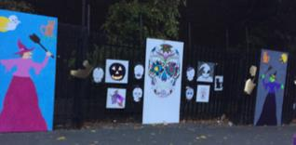Young people participated in a workshop with volunteers from The Abbey Theatre on how to use Halloween Make-Up and spent six weeks preparing for the drumming which led the parade from all the various communities.

The **Adult Programme Participants** took part in special cooking classes where they made unique cakes for Halloween.

The children in our **crèche** spent many weeks making Halloween decorations and had a magician entertaining them before the Halloween parade.

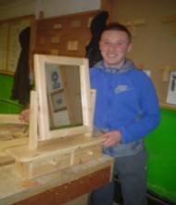**Community Training Centre (CTC)**

## Role of LYCS CTC: is to provide 40 young people (between 16 and 21 years) the opportunity to gain certified training in QQI (Formerly FETAC) Awards at Levels 3 and 4 and Personal Development Programmes each day; and to assist learners develop progression routes into further education/training or employment

**LYCS CTC 2016**

48 young people attended the centre in 2016.

* 7 progressed to employment
* 16 progressed into further education
* 5 left voluntarily

**The CTC runs 4 main programmes:**

Childcare; Woodwork; Sport and Recreation; Pre PLC and Employment.

**Over 200 certificates were achieved by learners in 2016**

**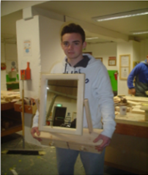***LYCS CTC offers the following modules at levels 3 and 4*

|  |  |
| --- | --- |
| * Business English * Career Preparation * Child Development and Play * Childcare and Safety * Communications * Craft: Ceramics * Customer Service * Food and Nutrition * Functional Maths * Health Related Fitness * Human Biology * Info Tech Skills | * Internet Skills * Mathematics * Personal & Interpersonal Development * Personal Effectiveness * Pyrography * Soccer * Understanding Inter-culturalism * Woodcraft * Woodturning * Woodwork * Work Experience |

## Description of Client Group Being Served

LYCS aims to work with 16-21 year olds who can be sub-divided into the following categories:

* Young People who have left school early without any certification
* Young people who have passed Junior Cert Level albeit with poor grades and who still require support to access employment or further education
* Young people with special needs / at risk
* Young people who have passed the Leaving Certificate/Leaving Certificate Applied albeit with poor grades and who still require support to access employment or further education.

**Progression 2016**

LYCS CTC is proud of all learners who participate on the programme and in particular proud of the successes of many learners who go on to further education and employment. LYCS CTC emphasises the importance of career planning from the moment the young person starts in LYCS CTC. Each learner is assigned a Key Worker who meets the learner once per month to discuss the learners progress and assists the learner plan for their future. LYCS CTC has a full time Advocate (Career 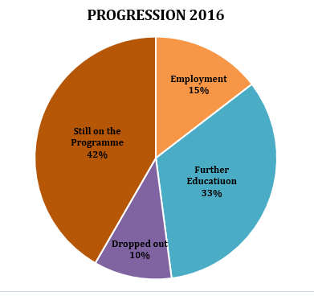Guidance Counsellor) available to meet with learners on a monthly basis to ensure a progression plan is in place for all learners.

**Learner Profile**

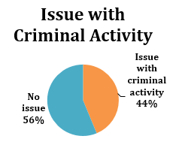LYCS CTC works with learners predominantly from the Dublin 1 and 3 areas. In 2016 over 80% of our learners were males. Changes to training allowance entitlements for lone parents in recent years has made participating on the programme more difficult and less attractive for this group. We believe that this is one of the main reasons for the reduction in the numbers of females attending the programme.

Learners are often sometimes faced with enormous challenges. Poor housing conditions, the prevalence of anti-social behaviour and drug use in the area has an effect on all of the young people in the centre with nearly half of learners being directly affected.

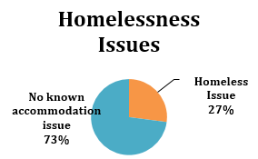The low numbers of local people progressing to further education discourages parents and young people to strive to progress. Many young people in the area live in very overcrowded homes, with teenagers sleeping on sofas in living rooms which leaves little opportunity for young people to do homework or get adequate sleep. According to TUSLA the Dublin 1 and 3 areas have the highest numbers of young people living in care nationally. In 2016 nearly 30% of young people attending the centre were living in care homes or homeless accommodation.

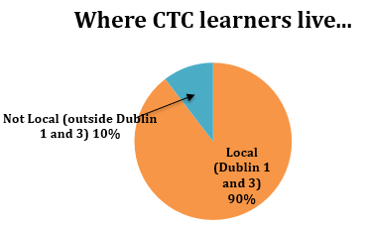**Work Experience**

Every Year LYCS encourages learners to participate on a number of work placements. The experience gained on placement helps the learner decide what career he/she wishes to pursue and help prepare the learner for the world of work.

**Literacy and Numeracy**

All learners are literacy and numeracy assessed on entry. Depending on their need, one to one and small group literacy and numeracy sessions are arranged. Learner’s progress is monitored regularly throughout the year and adjustments are made to the level of Literacy and Numeracy support as necessary.

## 

## Individual Learning Plans

Individual Learning Plans (ILP) are developed with the learners during their induction phase. These ILP’s are constantly reviewed by the learner’s Key Worker. During these sessions the learner’s progress is discussed and changes made to the plan where necessary.

**Access, Referral and Progression**

*Access/Referral:*

Young people who are not in school, between the ages of 16 and 21, are actively encouraged to seek admittance to the programme. Local organisations and schools regularly refer young people.

Each new learner is placed on an induction programme during which his/her personal, social, academic and literacy and numeracy skills are assessed. If we do not have place on a suitable programme, we will offer assistance finding a more suitable place of education/training elsewhere.

***Progression:***

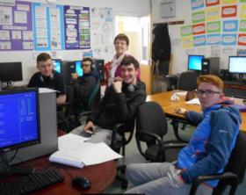Learners are encouraged to participate on work placements regularly to enhance their learned skills and to focus their attention on further education/training or employment options. When Learners are ready to progress they work closely with their Key Worker and Advocate to develop a personal progression plan.

**Community Employment (CE) Programme**

LYCS provides **work-based training places** for **thirty six** long-term unemployed people (age 25+). Twenty-seven of these places are based in LYCS and the 9 are based in local community organisations. The CE programme aims to meet the needs of individual participants on their journey from unemployment to employment. Through the provision of basic and softer skills training, and specific educational programmes, individuals enhance their self-confidence and employability.

**Programme Aims**

* To provide a structured training and employment programme for adults who are long term unemployed.
* To support participants in their transition from unemployment to work.
* To work with participants on an individual basis in an effort to meet their development needs and develop a training plan.
* To engage with sponsors and employers in the local area in order to provide meaningful and worthwhile work with a view to further training and progression.

**Places and Participation**

41 people participated in CE throughout 2016 in the following organisations:

|  |  |
| --- | --- |
| **Name of Project** | **Number of places allocated** |
| LYCS | 27 |
| Adventure Sports Centre | 1 |
| St Joseph’s Parish Church | 1 |
| Lourdes Day Care Centre | 3 |
| Community Technical Aid | 1 |
| Hill Street Family Resource Centre | 2 |
| Voluntary Services International | 1 |

**Work of the Scheme:**

* Recruit CE Workers for local projects, with the aim of targeting those individuals who will most benefit from being on a CE Scheme
* Providing funding to support staff in terms of wages, training, and materials
* Ensuring that participants are supported in their work, training and progression plans
* Providing information to participants on a range of rights and entitlements
* Ensuring that the Individual Learning Plan for each participant is implemented
* Providing one to one support in job seeking skills, C.V Preparation, Interview Skills, and job exploration
* Supporting individuals to make the transition from unemployment to employment
* Following up with participants who have left CE in the last six months to provide them with ongoing support to help them find employment or further training opportunities

**Progression on Community Employment in 2016:**

13 participants left CE in 2016, **54%** progressed onto employment/education

**Community Employment Training**

LYCS offers participants a variety of both certified and uncertified training options in line with participants development needs. In 2016,

20 participants took part in certified training

11 participants took part in uncertified training

**Accredited Training (Minor Awards)**

|  |  |  |
| --- | --- | --- |
| **Number of Participants** | **Level of Training** | **Award** |
| 9 | QQI level 5 | Early Childhood Education |
| 1 | QQI level 6 | Supervisory Childcare |
| 3 | QQI level 5 | Health Care Support |
| 1 | QQI level 8 | Social Science |
| 1 | QQI level 5 | Facilitation Skills |
| 1 | QQI level 5 | Coaching skills for Caseworkers |
| 1 | QQI level 5 | Business Administration |
| 2 | QQI level 3 | English Literacy |
| 1 |  | Foundation in Art Therapy |
| 5 | QQI level 5 | Occupational First Aid |
| 1 | QQI level 5 | HACCP – Food Safety Certification |

**Un-accredited Training**

|  |  |
| --- | --- |
| **Number of participants** | **Type of Training** |
| 2 | Fit for life programme |
| 1 | Pottery |
| 1 | Well Being |
| 4 | Manual Handling |
| 3 | Child Protection Training |

**Major Awards Achieved 2016**

Three participants received QQI Major Awards in 2016

|  |  |  |
| --- | --- | --- |
| **Number of participants** | **Level of Award** | **Name of Award** |
| 1 | QQI level 8 Honours Degree | Social Science |
| 1 | QQI level 5 Certificate | Health Care Support |
| 1 | QQI level 5 Certificate | Early Childhood Education |

**Adult Education Programme**

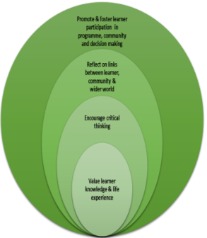

**Mission**

*LYCS aims to create a variety of learning opportunities for our community, prioritising people living locally and people experiencing poverty and social exclusion.*

**Vision**

*LYCS Adult programme is seen as a* ***hub and haven of hope and development****. We aim to create a welcoming, friendly, supportive and safe environment where good communication and relationships are fostered.*

**Service**

*Offer education that is learner centred and participative; values people’s knowledge and life experiences and encourages critical thinking, problem posing and analysis*.

**Figure 1**: Elements that underpin the work of the adult programme

#### **Overview of the Year**

During 2016, up to 130 **men and women** took part weekly in the Programme's activities, with a significant influx of new participants. The sessional tutors and volunteers continued to demonstrate their dedication and commitment.

There was an average weekly attendance of 65 people.

**Registration & Outreach:**

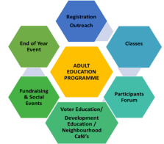

**Flyer** was distributed to over 1,000 households, local shops/projects and was e-mailed to 70 local organisations.

**Visits to schools to engage parents:** Gardiner St National School, North William Street Infant Boys and Lourdes Parish School were visited. Close contact was kept with the Home School Completion programme.

**Registration Day**: 35 new local people registered in September 2016.

**Local organisations**: LYCS continues to link with local organisations to explore ways in which their participants could be further supported by our Adult Education Programme. For instance the BallyMacSheriff Halloween Festival saw the start of two new classes, cake decorating and choir, as a part of this initiative. Their success led to them being added to our 2017 curriculum.

**89% of participants** heard about LYCS locally, either by word of mouth or through a publicity campaign.

**Classes**

Our principle activity is the provision of free or low cost classes/courses for local adults. These classes/courses are delivered weekly by sessional tutors, core staff and volunteers, usually in three ten-week terms based on the school year.

|  |  |  |
| --- | --- | --- |
| **Day** | **Start time** | **Class** |
| Monday | 10:30 a.m. | Art |
|  | 10:30 a.m. | Stained Glass |
|  | 11:00 a.m. | Cookery |
| **Tuesday** | 10:30 a.m. | Sewing |
|  | 2:30 p.m. | Tai Chi & Relaxation (Community Wellness) |
|  | 7:00 p.m. | Improvers Computers |
| **Wednesday** | 10:30 a.m. | Knitting Group |
|  | 10:30 a.m. | Pottery |
|  | 7:30 p.m. | Improvers Computers (QQI 3) |
| **Thursday** | 10:30 a.m. | Well-Being |
|  | 10:30 a.m. | Cake Decorating |
|  | 10:00 a.m. | Computers Beginners |
| **Friday** | 9:30 a.m. | Cookery |
|  | 11.00 a.m. | Drama |

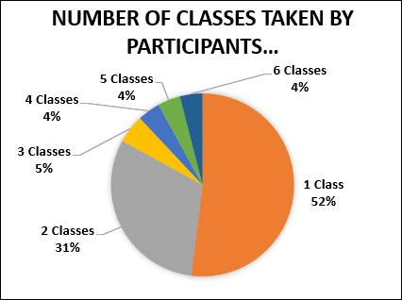Learners reported the following benefits from attending classes: meeting new people; gaining new skills and knowledge; being part of a creative and social outlet; increased self-confidence; working with open & friendly tutors, relaxed & supportive pace of learning in a positive atmosphere.

**'Participants' Forum'** enables participants to become involved in planning, implementing and monitoring the Programme's work. Two members of the Participants' Forum joined the Management Board of LYCS.

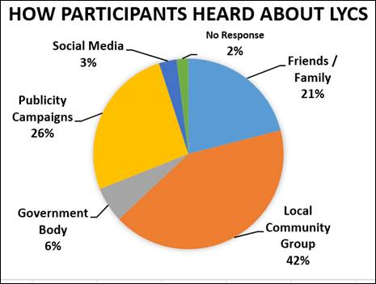**End of Year Event**

Up to seventy participants, tutors, guests and staff took part in the annual 'End of Year Event', inJune in our Crèche hall. LYCS certificates were presented to participants by special guest Senator Lynn Ruane, (outgoing Trinity College Student Union President). Senator Ruane shared her first-hand experience of the transformative power of education as an early school leaver and participants' descriptions of their experiences of LYCS helped to create a warm and happy atmosphere on this evening of celebration.

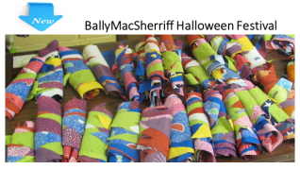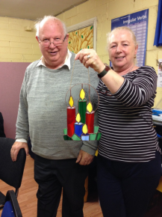

**New in 2016:**

**Bunting for the Halloween Festival** made by the Sewing Class

**Cake Decoration:** A group of creative men and women met every Thursday to fashion seasonal decorations e.g. bloodshot eyeballs, skeletal fingers, spiders weaving their Halloween webs, Christmas Santas, presents and penguins.

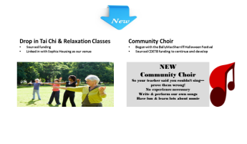September saw the first meeting of the NIC **Community Choir** as they prepared a performance for the BallyMacSheriff Halloween Festival. Sean Millar composed a song for the event based on interviews he had had with local residents living in the North Inner City.

Drop-in **Tai Chi & relaxation** classes began in the autumn of 2016. These classes teach and practice very simple wellness exercises which promote feelings of peace, vitality and relaxation. One participant said ‘*I float out of there, and think of it during the week when I want to lose it, but then I don’t’.*

**Development Education Programme**

* Poverty * Inequality * Human Rights * Gender * Food and Hunger * Migration * Environmental * Sustainability * Democracy * Racism *

**335 Participants on a variety of training and workshop events**

The Development Education (DE) programme aims to provide opportunities for people to explore the development challenges faced locally, in Ireland and in communities around the world. It fosters critical thinking, active citizenship and a sense of shared struggle for a more, fair and equal world.

**2016 Highlights**

**100 people** participated in **1916 Democracy Café** who chatted and shared about how democracy can be made stronger. The Café was the culmination of a **Global Democracy Project** whichfacilitated the discussion of democracy in Ireland and worldwide, against the backdrop of the 1916 centenary. In addition to the café, workshops for local residents and training for trainer’s sessions for community educators took place.

**84 people** participated in **2 Neighbourhood Café Series:** Inspired by the success of 1916 Café, a local collaborative partnership brought residents together to share current issues in the community. As part of our contribution, LYCS brought a global perspective and speakers from the global south to this inspiring community process.

**83 people** participated in **themed trainings for practitioners and activists** including: Women of the World; Food & Sustainability; Migration; Transforming our World through Music; and Facilitation Skills which built their capacity to engage others in this kind of learning

**11 asylum seekers** and Irish people participated in an innovative **global development course** in Mosney Accommodation Centre.  Participants explored issues such local and global poverty, migration, culture, the legacy of colonialism, racism and development.

**45 residents**, transition year students and environmental projects participated in a creative and participative ***Waste Not, Want Not* Fair** aimed at raising awareness of our ‘throwaway’ culture and promoting reusing, repairing, upcycling, recycling and donating and saving money in the process.

**Sectoral Leadership:** Irish Aid launched their new DE Strategy. LYCS has played a key role in engaging with the DE sector and Irish Aid to promote an understanding of how local-global learning can be an effective educational tool for the community sector. Our experience and engagement is reflected in the new Irish Aid strategy.

**Management Board**

**Jackie Lawlor Chairperson**

**Linda Costello Treasurer**

**Bernie Walsh**

**Dave Little**

**Jean O’Connor**

**Una Shaw**

**Kevin Reid**

**Will Peters**

**Peter O’Connor**

**Nessan Vaughan**

**Jim McLoughlin, Staff member**

It was with great sadness that Joe Kelly passed away after a short illness in December 2016. Joe, had been involved with LYCS and community development in the north inner city for many decades. He took a creative approach to solving problems and had a commitment to ensuring local people were actively engaged in their own development. He was brave in promoting the principles of equality and justice and encouraged others to do so too. He is sorely missed by everyone in LYCS.

**Childcare Programme**

**Steps Crèche and Pre-school**

**Youth Programme**

**Centre and community based youth programmes**

**Community Training Centre**

**Education & training for young people**

**Adult Education Programme**

**An informal training, educational and social programme**

**Community Employment Scheme**

**Development Education**

**Social Analysis Education with a global perspective**

**Tel: 823 0860 email: deved@lycs.ie**

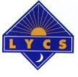

**Acknowledgements**

LYCS acknowledges the funding and support provided by a range of Government Departments, Statutory Agencies and funding bodies and looks forward to continued positive and productive working relationships in furthering the development of project participants.

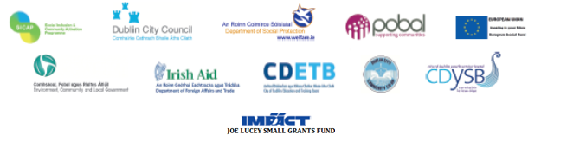

**LYCS, Lr. Sean MacDermott Street, Dublin 1**

**Telephone: 01 836 3416 and 01 836 5984**

**Fax : 01 855 6445**

**Email:** [**lycs@lycs.ie**](mailto:lycs@lycs.ie)

**Website:** [**www.lycs.ie**](http://www.lycs.ie)

**Facebook:**



**LYCS Adult Education Programme**

**LYCS Development Education**

**LYCS CTC**

**LYCS First Steps Crèche**

**LYCS Youth Work Programme**